**Guard Tour Management Software**

**User’s Manual**

**5005**

5005 Installation Guide

**1. Preparation**

a. Make a sketch of the sites and name all the check points where the RFID cards will be installed e.g. front door, back door, etc. Besides, make a list of all persons you want to monitor, which will be used for the guard ID cards.

b. The sketch will be helpful for customers to assign the RFID cards in the software and physically screw the correct RFID cards at the correct check points.

C. according to the circumstances, the RFID cards can be screwed on the walls, doors, furniture, fences, trees etc.

**2. Initial setup Flows**

Login-> Initializing-> Guard Setup -> Route Setup-> Checkpoint Setup-> Event Setup-> Tour Plan

**3. Software Installation**

3.1 **System Requirement**

a. Operating system requirement: Windows2000 / XP, Windows Vista, Windows 7, Windows 8

b. Minimum hardware requirement: MMX Pentium 233MHz CPU, 32 MB RAM , CD ROM drive, RS232/USB port, the min screen resolution 800x600

**3.2 Software Installation**

a. Insert CD on the appropriate drive

b. Program contains an auto-run (start) function. If the following icon appears, double click it and finish installation.

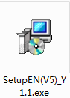

C. when the installation starts, follow the instructions on the screen and install the program in less than 5 minutes.

**4. Initial Setup**

**4.1 Log in**

a. After the software installation, click the icon "Patrol Management System", and the system will launch a user login dialog box as shown below.

b. By default, the software requires a username and password to operate. For first use, you can get password in Tip.

c. For master user, choose the default username "master", and the default password is "999";

For regular user, choose the default username "user", and the default password is "123".

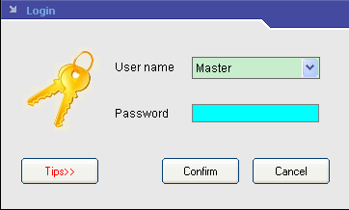

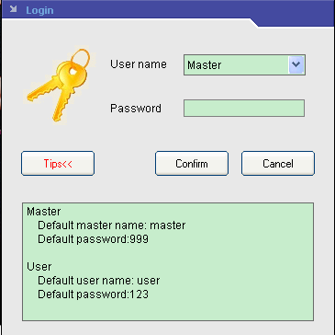

d. In fact, this is a multi-level operator system, so you can reset the username and password at different level operator system in Operator Management (For details, refer to the following instructions about Operator Management.)

**4.2 Initializing System**

a. Reset and initialize the memory of the reader and the system.

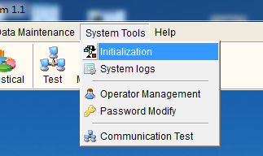

b. Press System Tool, and then click Initialization, there are several options, choose the items you want to have initialized, and then, all data stored in the reader and the system will be canceled.

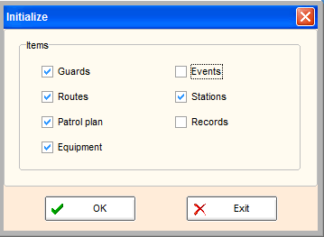

c. When the system is operated for the first time, or a reader is used on the system for the first time, it is recommended using it, so all the useless records will be eliminated.

In addition, please connect the reader to the software, and then click ‘read data’ in order to clear the useless records in the reader.

**4.3 Guards Setup**

a. In the item of Patrol Setup, click Guard Setup to add, delete or modify guard ID cards.

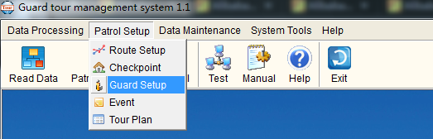

b. There are two ways to add the ID number of the guard cards to the software. 1. Read ID cards and connect the reader to the computer, then click 10 button; 2. Please note that click ADD button, only the guard name can be added, but the card number can’t be added, which just fit for the condition without ID cards.

We recommend customers to use guard ID card and click batch add button to add card number to software.

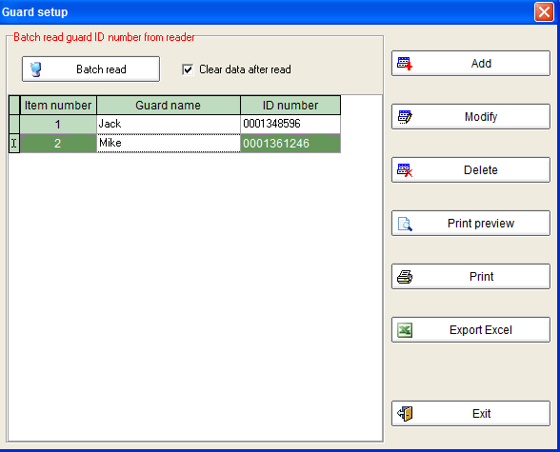

Please note: there is "Clear data after read" option on the right side of “batch read” button.

If the "Clear Data after read" is clicked before Batch Reading the card ID from the Reader, all the information will be eliminated from the Reader after batch reading the card ID from the Reader.

If the "Clear Data after read" is not chosen, all the records (refer to the card ID number) will still be stored in the Reader, and you can still use them in other aspects.

In order not to mass all the setup, we recommend “clear data” when you batch read data from the reader.

**4.4 Route Setup**

a. Open up the Setup Routes screen by going into the Patrol Setup.

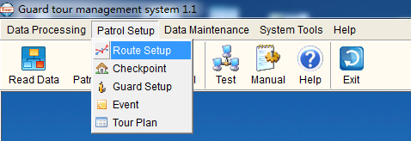

b. Click Route Setup to add, delete or modify routes.

c. Click Add to add new route. Enter a Route number and Route Name (for example: Route number: 1, Route name: warehouse)

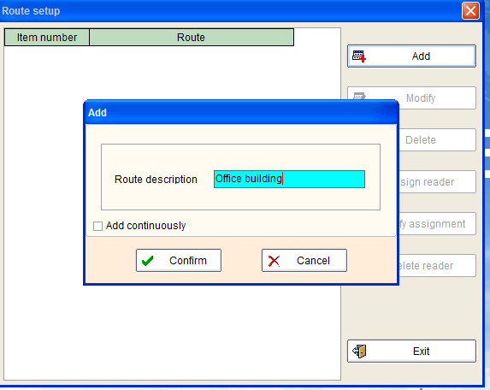

d. Please note: you will see there is a button named44, if this route is without tour plan, you must make a reader to match this route (which means this reader can be only used in this route); otherwise all the patrol records will not be allowed to be uploaded to the software after you finish patrol.

However, if there is a tour plan for the route, this item will become an optional item, you can choose to match a reader to it or not.

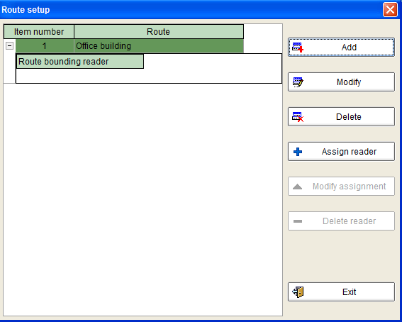

**4.5 Check point Setup**

a. In the item of Patrol Setup, click Checkpoint to add, delete or modify.

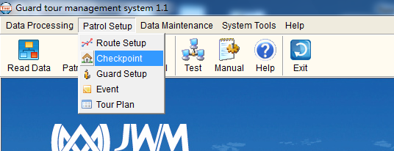

b. Before editing check point information, choose a route in which you want to add check points first, e.g. warehouse, and then set up the information as you want.

c. To add each card manually; after selecting the Route name, click Add on the left hand side.

d. The following screen will pop up. Enter the card ID number and the check point name.

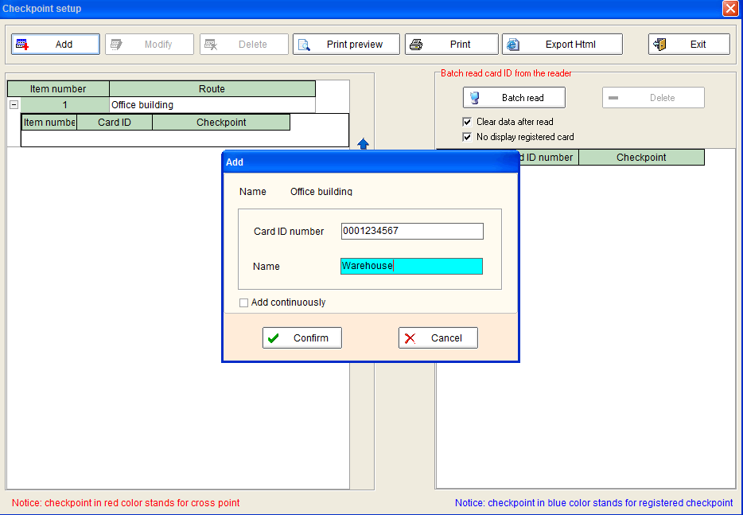

e. To do a batch read automatically; use the Reader to read each card in the sequence that you want, then connect the Reader to computer and click 10 and then all the card ID number will be shown on the right blank as following.

*First choose a route record, and then add EMID signal card ID and the station name.*

*Two ways to add the EMID signal card information: 1. click Add, 2. or click BatchRead when connecing the reader to PC after the reader collecting EMID signal card ID. then save them when click on*

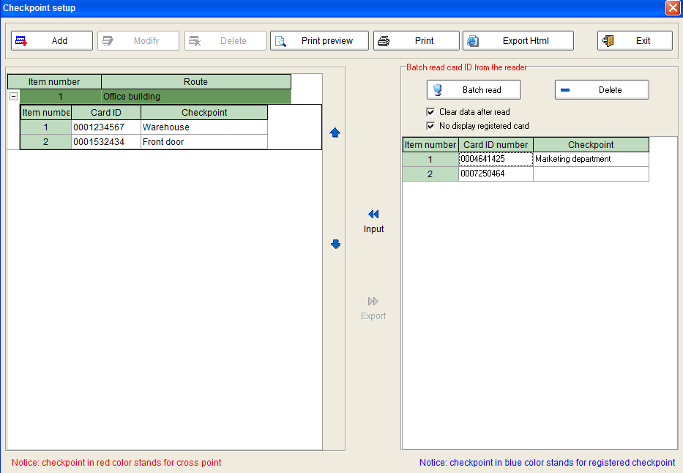

f. And then you must assign each card ID with the respective check point names and put them into the correct route; you can do as follows: select available ID records and click 9 to save them. After adding and modifying, all the information will be saved and displayed on the left hand side as shown on the “Route Setup” screen, which are shown under a route name.

Please note:

There is "Clear data after read" option on the right side of the screen.

**4.6 Event**

a. An events (incident) book with cards can be defined and setup for the guards to carry during the patrol.

b. For example, the guards can carry 4 cards with the following predefined events:

card 1: Hidden fire danger

card 2: Unlocked door

card 3: Raw materials lost

card 4: Lights still on

When the guard encounters any of the incidents above mentioned, he can automatically read the card with the Reader to record these events automatically with time stamps.

c. To use this function, these sets of signal card should be pre-defined in the Events Book by clicking Events Book, and you can find it in the item of Patrol Setup.

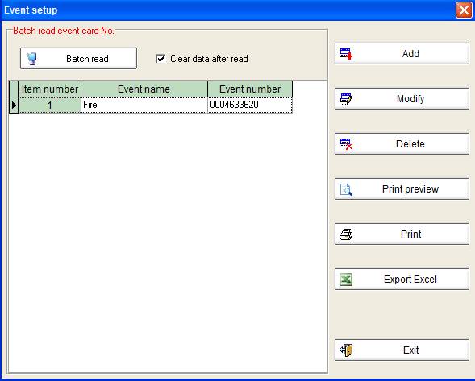

Steps for batch add event card number is the same as that of the guard setup.

**4.7 Tour Plan**

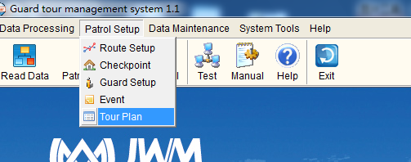

a. First choose a route which you want to set up a tour time plan. Please see below.

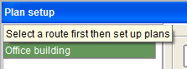

b. Then click13, another window will pop out, first choose tour plan start date , if there is a holiday, you should also choose holiday item. .

c. If the tour plan has a disciplinary, you can click 15 to have a time setup.

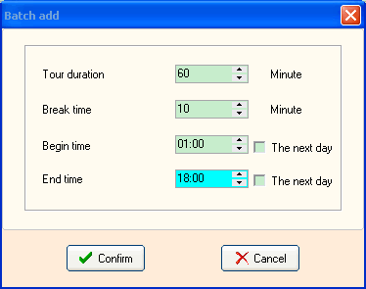

d. If the tour time is without a disciplinary, please click48, and then add tour time. Please see below.

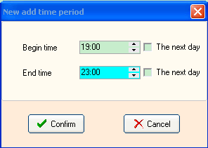

When you finish time setup and click “confirm” button, you will see time setup information on the Plan Setup window.

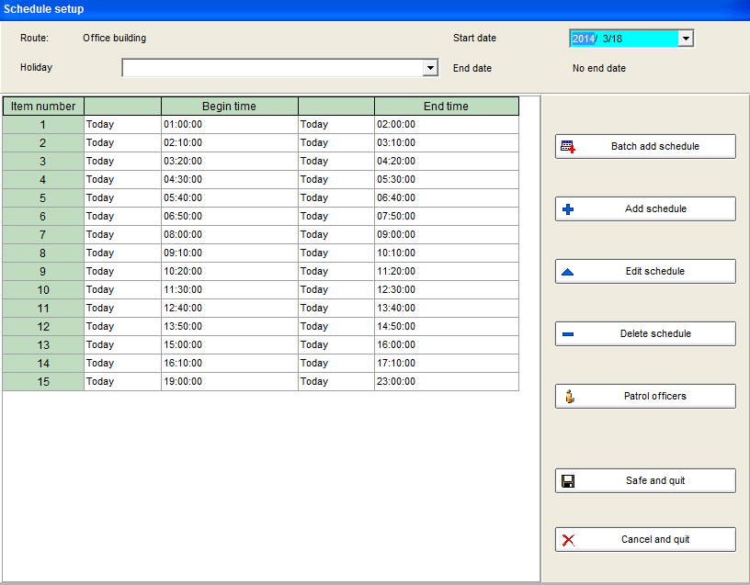

e. After the time setup, please click  to add guard in the route.

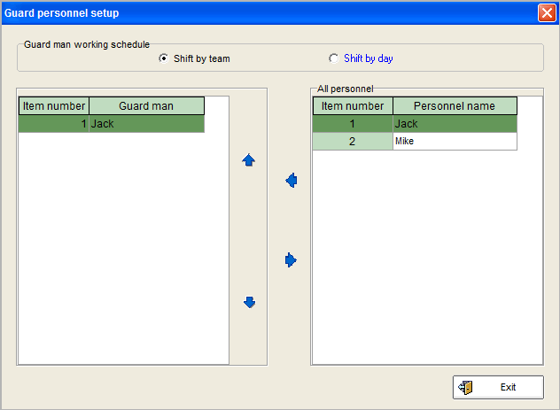

**5. Data Maintenance**

**5.1 Data Backup and Restore**

a. customers can back up the database on a regular folder of the computer.

b. To backup the saved database and all the setup process during the setup as above mentioned, customers can click “Backup data” as shown below.

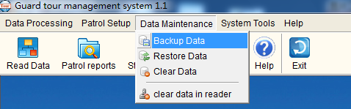

c. After clicking the button, you should save the backup file. Give a meaningful name and choose the destination folder to save the file into.

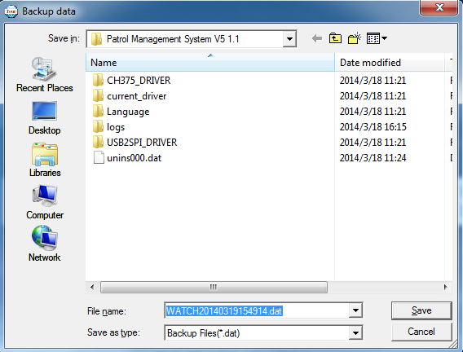

d. if the data in the database is lost, customers can restore the data from the backup drive or from diskette. To restore a saved backup file, simply click “Restore data”

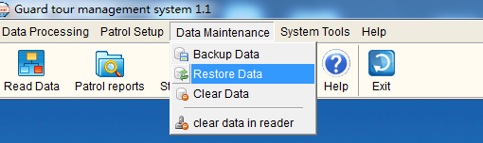

Click on the Restore option. The Restore Data window will pop out. Select the drive and directory from which to restore the data.

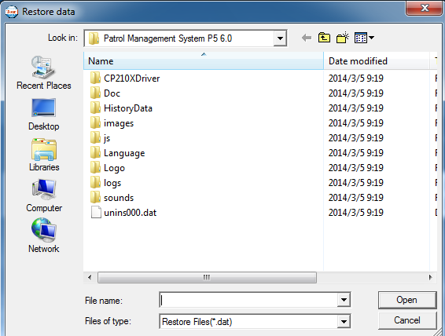

**5.2 Clear Data**

a. if the database contains too many data, the speed of the software will become slow, so the old data should be cleared in time.

b. In the item of Data Maintenance, click Clear Data, and the following screen will pop out.

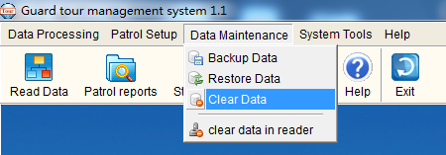

c. Choose the time during which there are data you want to clear, and then click Clear Data.

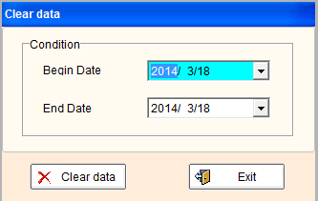

**6.System Tools**

* 1. **Operator Management**

a. Our guard tour system is multi-level operator system; operator with different level has different access rights.

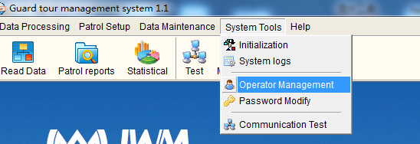

b. Press System Tool, and choose Operator Management, and then click on Modify to reset username and password at different access level. Customers can click Add to add new username and password.

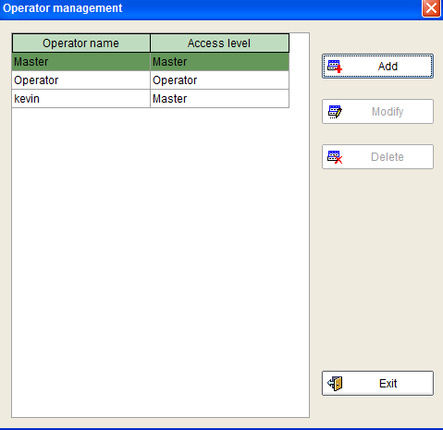

c. There are two login operators, and each is with different levels of rights:

|  |  |  |
| --- | --- | --- |
| **Access Level:** | **"User"** | **"Master"** |
| Initial Username | operator | master |
| Initial Password | 123 | 999 |
| Allows Data Reading and Query | Yes | Yes |
| Allows Test Reader | Yes | Yes |
| Allows Modify User's name and Password | Yes | Yes |
| Allows Modify Master's name and Password | No | Yes |
| Allows System Setup | No | Yes |
| Allows System Maintenance | No | Yes |
| Allows Reader Initialization | No | Yes |
| Allows Input of Basic Data | No | Yes |

**6.2 Password Modify**

a. In the item of Maintenance System, click Modify Password

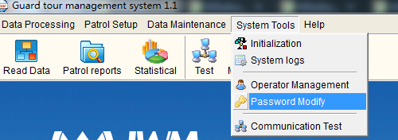

b. Then the following screen will pop out. Enter the current Password and the new Password, and then click OK. (The password can not be more than 6-bit number)

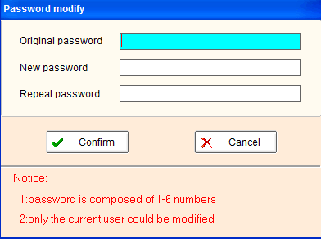

**6.3 Communication Test**

a. Click on System Tool, customers can find the item of Communication Test.

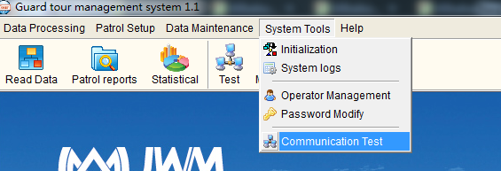

b. This item performs the following functions:

i. Checking whether the reader is connected with the computer well or not.

ii. Modify Reader ID. Each Reader is with a set ID number in it, which can be modified.

c. Click Communication Test, the following screen will pop out. After connecting the Reader directly with the computer, click Read ID, and then this Reader ID will be shown on the top blank.

d. You can also change the Reader ID in itself to 4-bit number you want. Just click Modify ID, or enter a new 4-bit ID number in the bottom blank manually.

**6.4 Initializing System**

a. Reset and initialize the internal memory of the reader and computer.

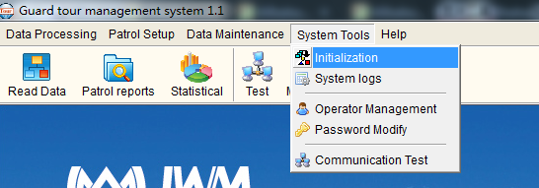

b. Press System Tool, and then click on Initialization, there are several options, choose the items you want to initialize, and then, all data stored in the reader and system will be erased.

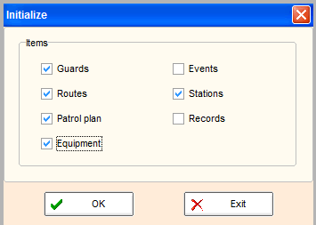

c. When the system is operated for the first time, or a reader is used on the system for the first time, it is recommended to make initialization, so that all useless records can be erased.

**7. Data Processing**

**7.1 Reading Data**

a. Click on51 on the main screen

b. Then the following screen will pop out. After connecting the Reader with the computer, click on Read Data button, and then the data in the Reader (condition for patrolling, such as guard name, time cost, route, station, time, date and incidents etc.) will be transferred to the computer.

During the process of reading data, the software will automatically arrange the records, and incomplete tours and omissions will be shown here.

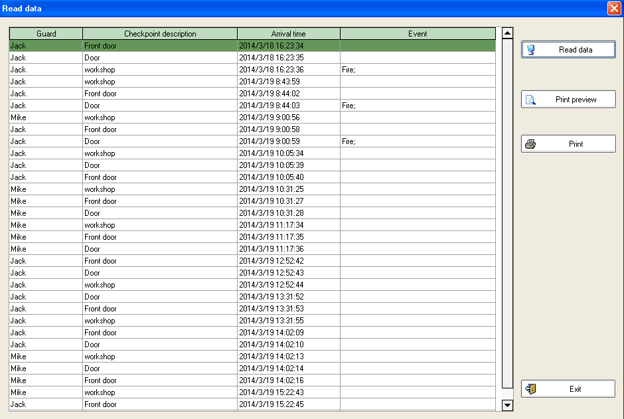

**7.2 Patrol Report**

a. By this function, you can check all that you want. Click 52 on the main screen.

b. Then the following screen will pop out. Choose date range (Start Date, End Date) to check the patrolling reports, and all the data will be shown on the following screen. Methods for further check is the same as that of section c,d of Reading Data part.

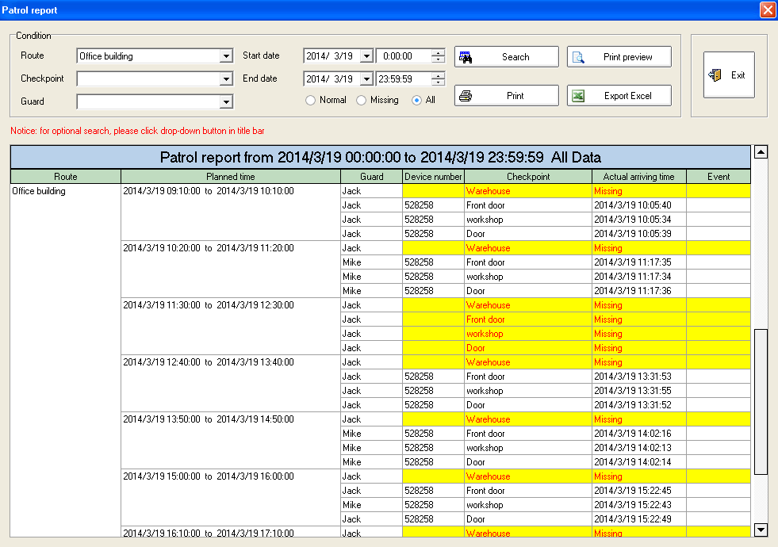

c. As for the conditional check, click the button {933091E4-B2DC-4FEC-9B10-E068A8D7A0DD} on the right of each title bar, then choose Custome Filter . A custom filter screen below will pop up.

d. Choose condition buttons, and input range for time, data etc., and then click OK to have a conditional check.

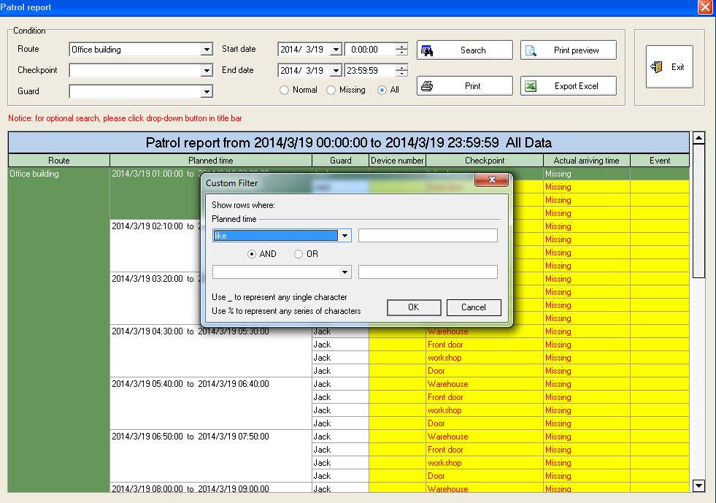

**7.3 Statistical**

Click Statistical button on the main screen.

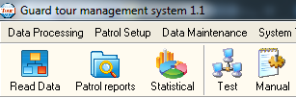

a. First, choose start date and end date you want to have a statistics, and then choose statistical way. If you want to see guard statistical result, then please choose Guard and click Stat. Button. Please see below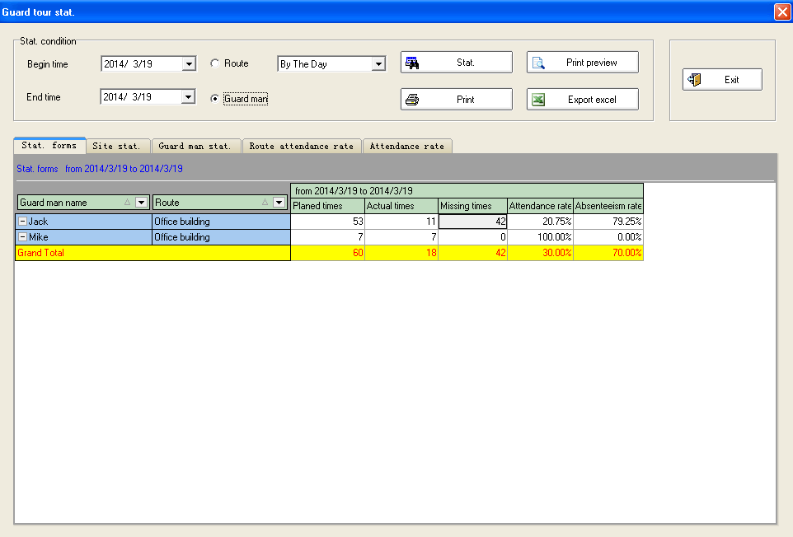

b. if you want to have route statistical result, then choose Route and click Stat. Button.

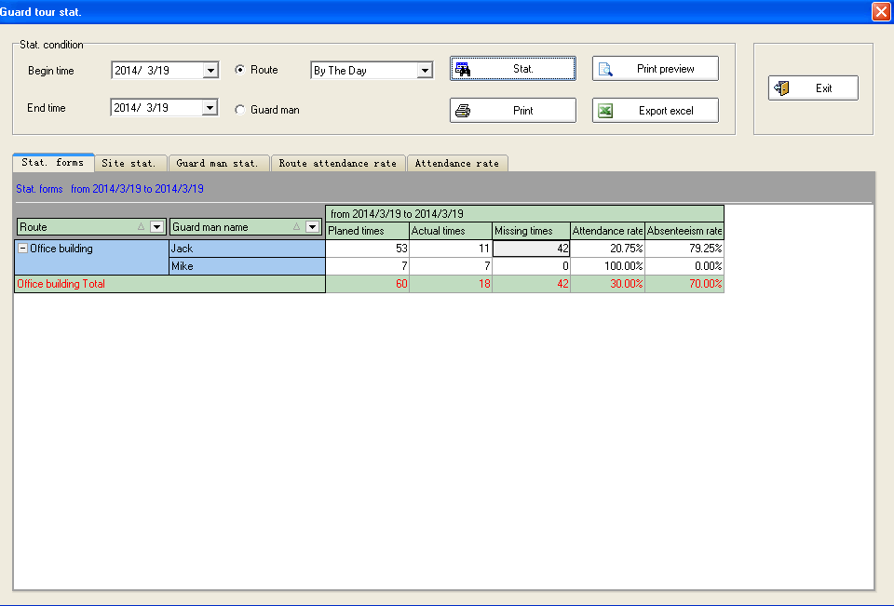

c. For conditional query, click the button {933091E4-B2DC-4FEC-9B10-E068A8D7A0DD}

In statistical, besides statistical table, there are also diagrams which show guards patrol conditions visually.

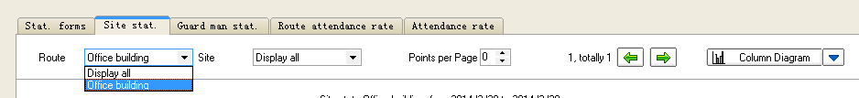

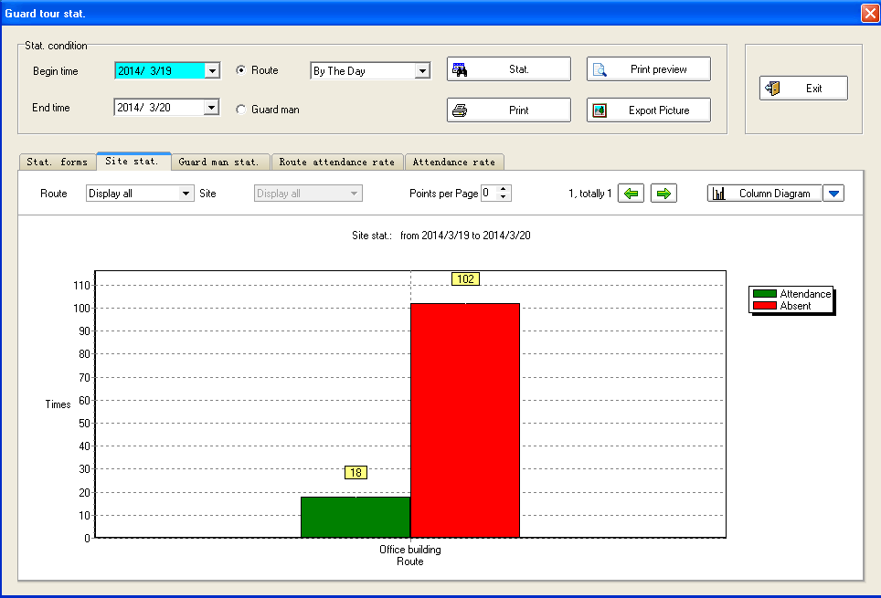

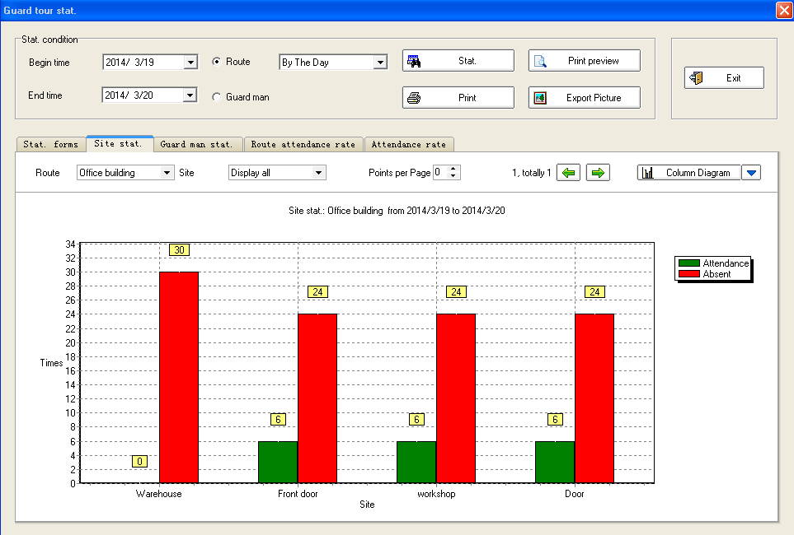

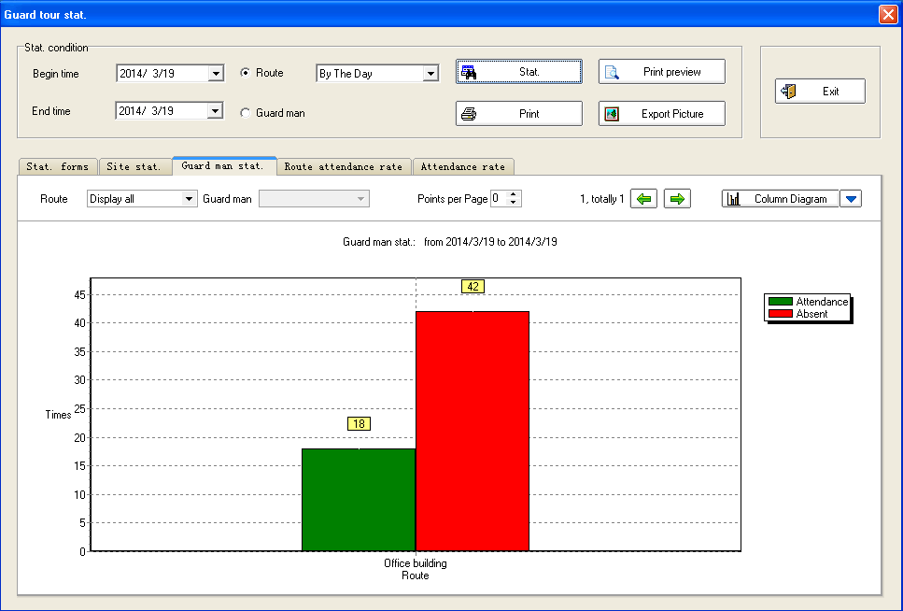

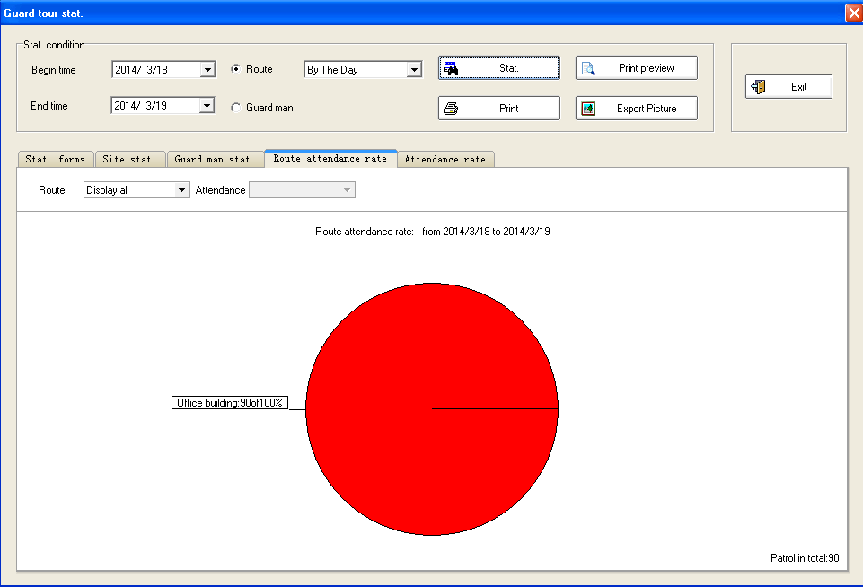

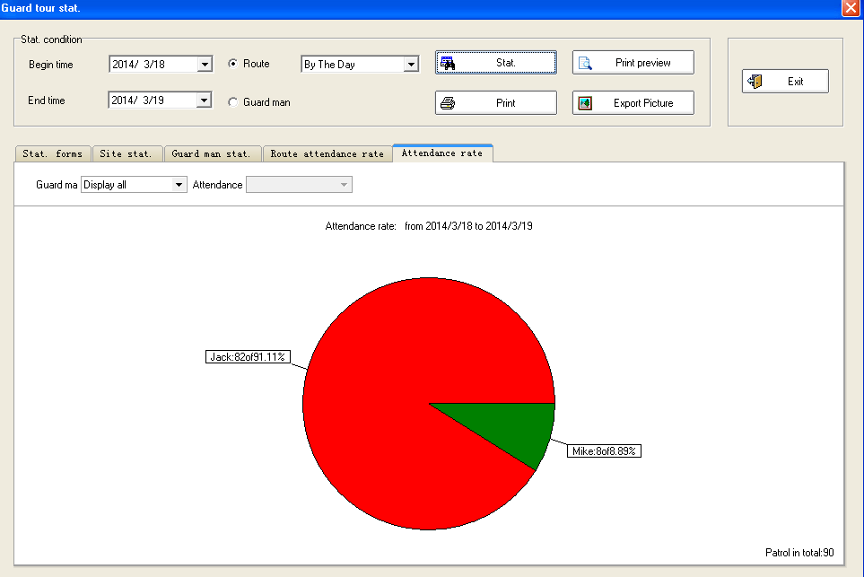

**Direction for use**

a. After software installation and setup, all the checkpoint cards have been edited with names (checkpoint names, personnel names or events), which are as same as being assigned in the software, and then fix these checkpoint cards to the proposed positions. Make sure that, the correctly named cards should be installed in the correct places of the proposed tour.

Besides, for the first usage, make sure the Readers ID have been registered in the software system via connections between Reader and computer.

b. When patrolling, first, the patrolling guard takes the Reader and read his own Guard ID to identify himself with the system, e.g. Guard A.

Make sure that the guard cards are not read in the middle of patrol routes, which can cause that the data will be showed by the software that no-name guards have the former part patrolling.

c. Then the guards go to the checkpoints, the Reader will automatically read each card. When reading successfully, a flash of the blue indicator light, accompanied by shaking one time, which means that a reading has been made. Then the reader will store card’s hexadecimal ID number in it.

d. After patrolling is done, connect the reader to computer.

e. Then download all the patrol data to software and have a data processing.